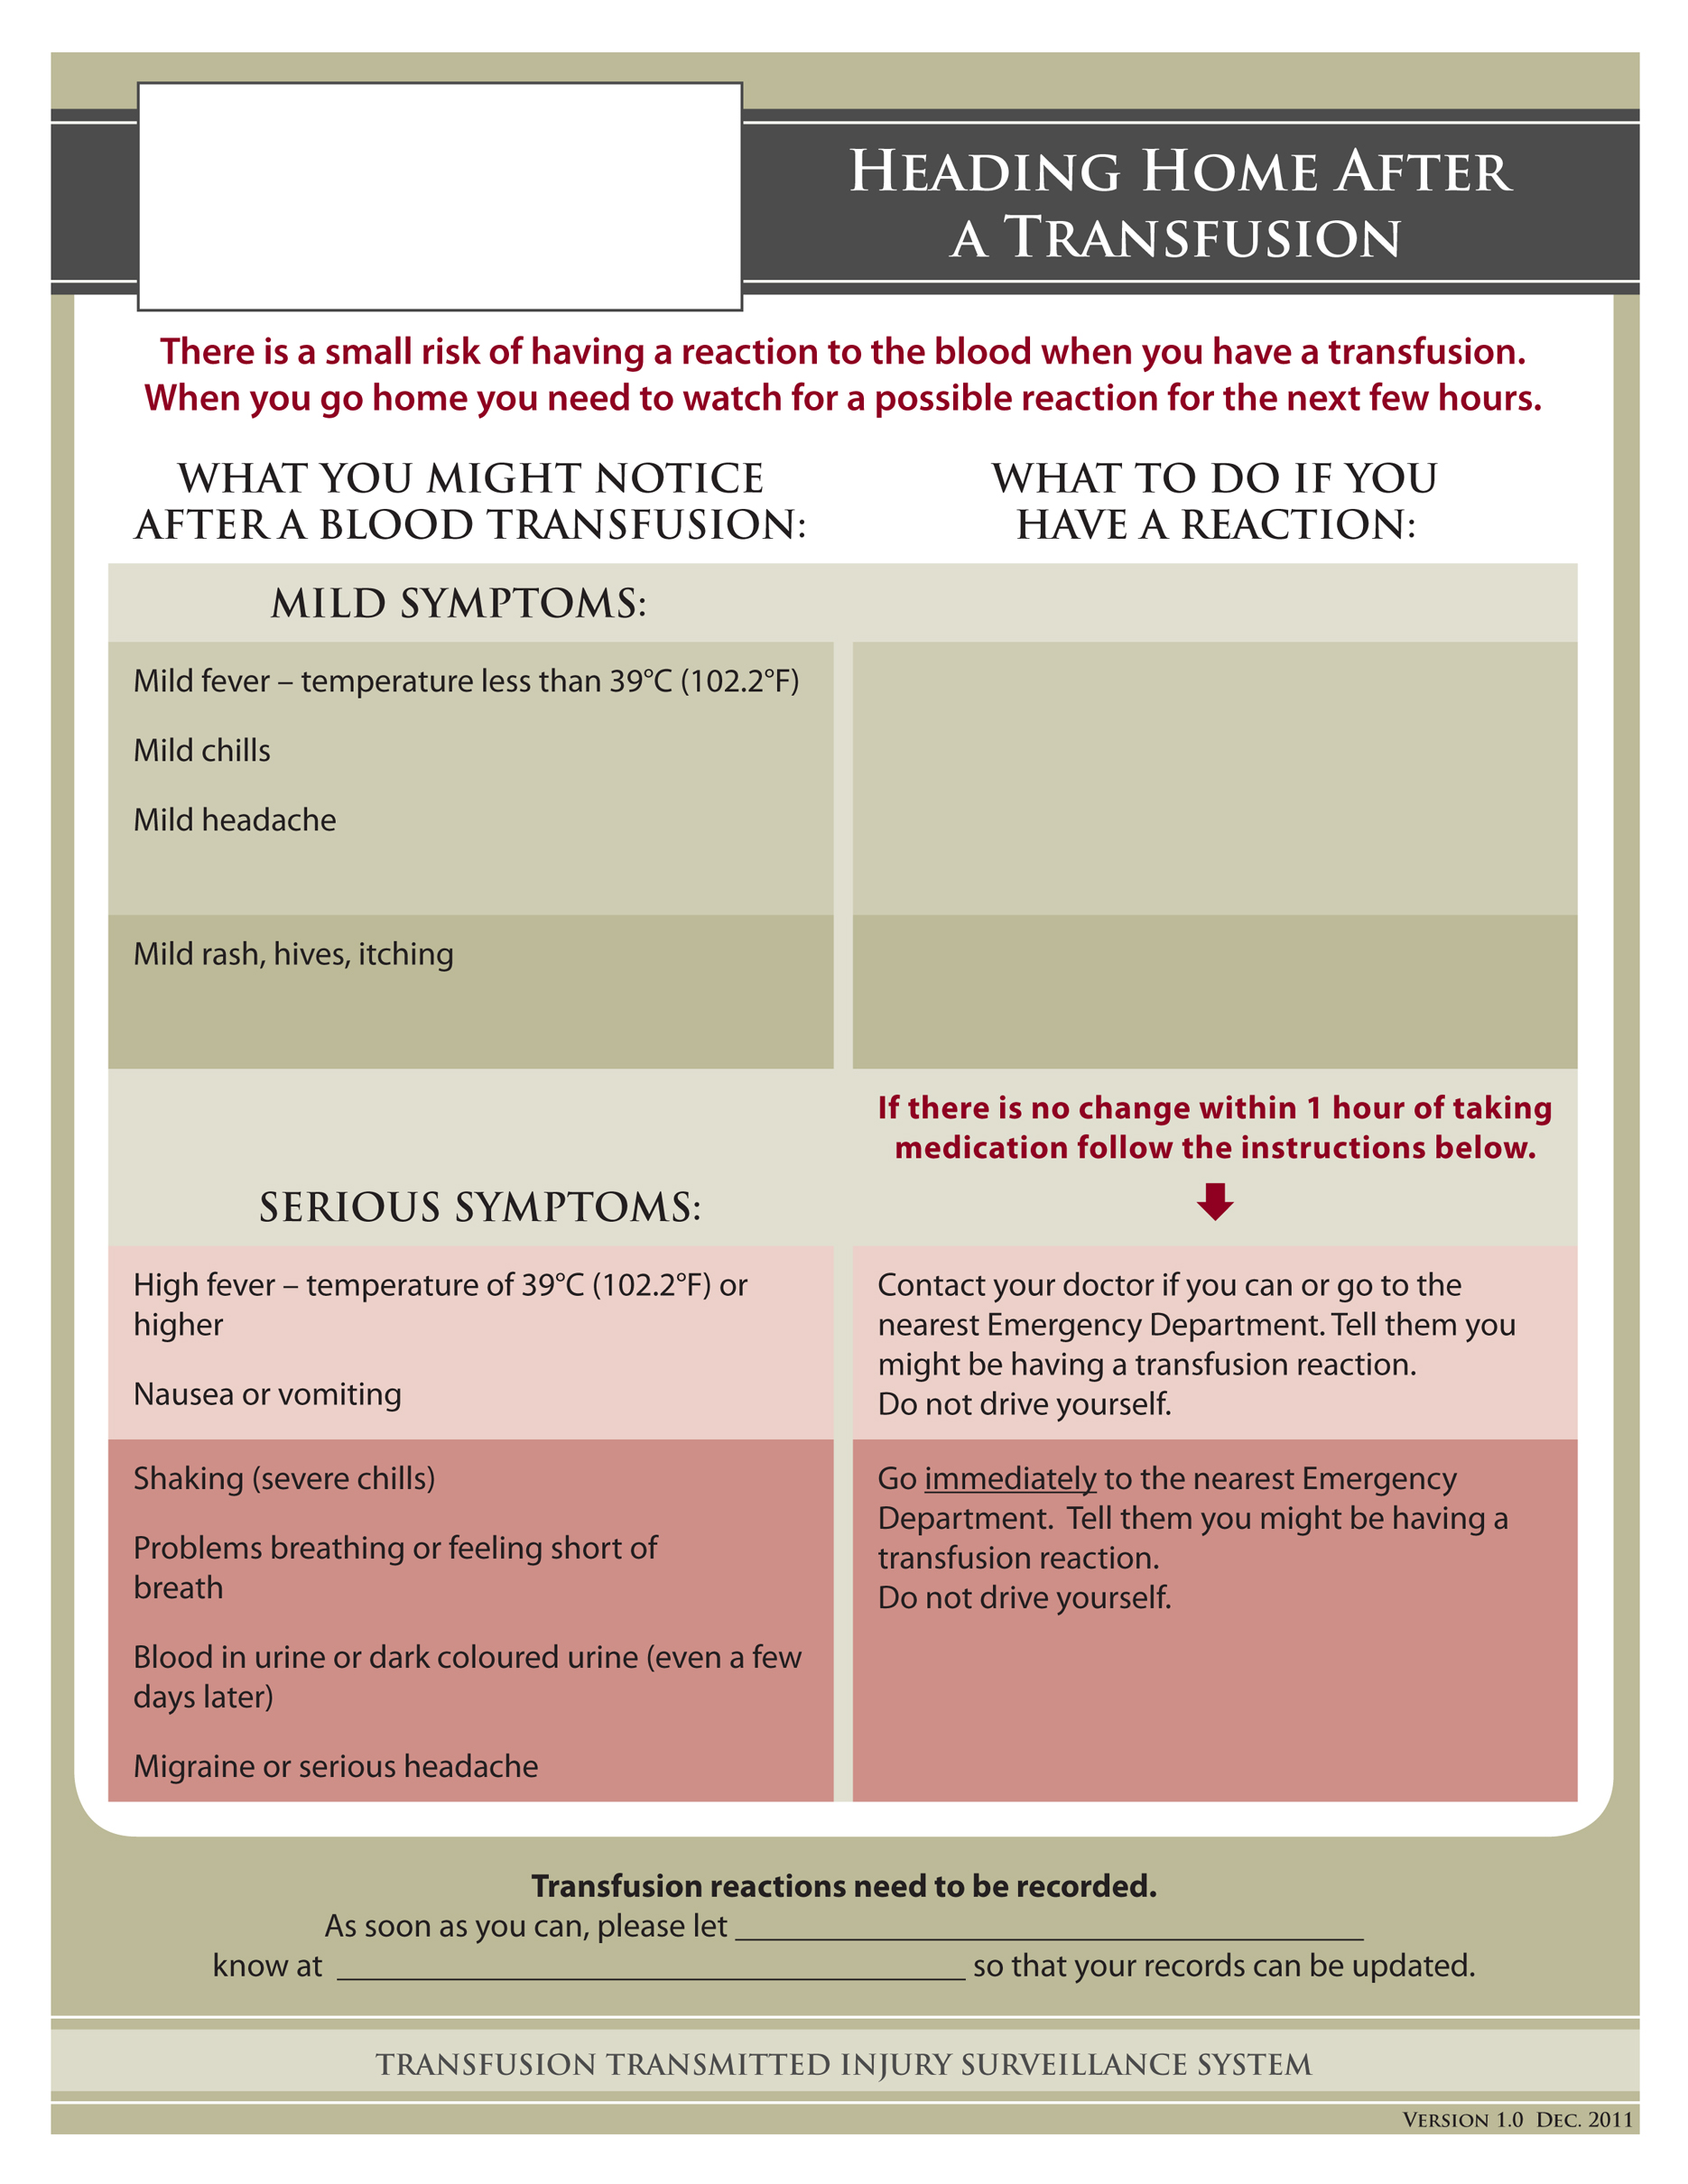*­­­*

Ontario

Transfusion

Transmitted Injuries Surveillance System



A non-prescription medication for allergies like Benadryl® or Reactine® may help your symptoms go away.

**Do not take any of the medication below if your doctor has told you not to. Always follow the directions on the package.**

A non-prescription medication for fever or headache like Tylenol® (acetaminophen) may help your symptoms go away.

input text here

input text here